“Referenz: http://www.car-to-car.org/index.php?eID=tx_nawsecuredl&u=0&file=fileadmin/downloads/C2C-CC_manifesto_v1.1.pdf&t=1399193195&hash=eff59efb9413b7a226296b9bfca14c91c9f968c0”

Car 2 Car Communication Overview:

Car 2 Car Communication (C2C-Communication) or Car 2 X Communication describes the communication between vehicles and other infrastructure. The goal is to improve the safety on the streets and to inform road user about upcoming problems on the road immediately. Therefore wireless communication protocols and standards should be defined, to guarantee the compatibility among different car manufacturers and roadside units. Furthermore the Car 2 Car Communication technology should be a basis for decentralized active safety applications and therefore reduce accidents and their severity. Besides active safety functions, it includes active traffic management applications and helps to improve traffic flow.

Car 2 Car Communication Actors:

One Actor of the System is the driver, which receives road information and warning messages or route recommendations. Another Actor is the road operator, which receives road information from cars or other infrastructure and therefore will improve the control of the traffic in a more efficient way. The last important actors are hotspot and internet providers, who can install their communication systems for example at gas stations.

Car 2 Car Communication Safety Scenarios:

1. Cooperative forward collision warning

This scenario should avoid rear-end collisions, for example if a following vehicle suddenly breaks. The vehicles share information about speed, position and heading. To avoid collisions, the system has to use the own vehicle information and the information of vehicles nearby. If the system detects a critical proximity, it will warn the driver.

1. Pre-crash Sensing/Warning

If a crash is unavoidable, information will be provided about vehicle size and exact position. Crash involved vehicles will exchange data about predicted impact zones, therefore airbags or bumper systems will be informed, where the impact takes place.

1. Hazardous Location Notification

The vehicle will inform about hazardous road conditions. If, for example, the ESP (Electronic Stability Program) is activated, the location and road condition will be transmitted to nearby vehicles. This information could be used for optimizing the chassis of the vehicle if it reaches the hazardous location. Such information is not limited to vehicles. Road signs could provide information over a token system, which will be served by external service providers.

Car 2 Car Communication traffic efficiency:

1. Enhanced route guidance and navigation

An infrastructure owner will provide information by collecting road data and predicting traffic conditions. Such information can be provided by a RSU (Roadside Unit), which transmits data about the region to the car. It can provide general information about the region or special information, depending on the route of the navigation unit in the car. The driver will be informed about expected delays or better routes that might exist due to the traffic conditions.

1. Green light optimal speed advisory

This Scenario should help the driver to make their driving smoother and avoid stopping. The information will be provided by signal intersections. The timing (when turns the light green) and exact location of the intersection will be transmitted. With this information, the vehicle calculates an optimal vehicle speed using the distance from the vehicle to the intersection and the time when the signal is green. The vehicle notifies the driver of the optimal speed. It’s the goal to increase traffic flow and to increase fuel economy.

1. Merging Assistance

If the vehicle wants to merge into traffic on a roadway, nearby vehicles will be informed about the approaching vehicle. The vehicle itself receives information about the current behavior of nearby vehicles. The assistance will guarantee that the vehicle can enter the traffic flow without major disruptions to the flow.

Car 2 Car Communication infotainment and other services:

1. Internet access in vehicle

The driver or the vehicle itself can access any information on the internet. If no vehicle or roadside unit is ahead, road information can be provided by the internet connection.

1. Point of interest information

The Point of Interest Notification allows local businesses, tourist attractions, or other points of interest to advertise their availability to nearby vehicles. In this case a roadside unit broadcasts information about opening hours or prices. The information will only be shown to the driver in appropriate situations. For example, if the fuel is running low, the vehicle presents the driver information about nearby gas stations.

1. Remote diagnostics

Remote diagnostic allows service stations to assess the state of the vehicle without a making physical connection. This would allow software updates directly to the car, without the need to drive to a service stations. When a vehicle enters the area of a service garage, the

service garage can query the vehicle for its diagnostic information to support the diagnosis of the problem reported by the customer. Furthermore the vehicles’ past history and the customers’ information can be loaded from a database to support the technician. With remote diagnostics, the time in service garages will be reduced and it will also result in lower cost for repair.

Wifi Direct Raspberry Pi:

What you need to use Wifi Direct on the Raspberry Pi:

First of all you need the raspberry pi with at least 2 GB SD Card and a Power supply. The power supply should deliver a minimal power of 1000 mAh, otherwise the USB and the Pi in general would shut down because of power loss. The Prototype system is a Debian Linux (Raspbian). The installation process will be described later. For Wifi direct usage you need a compatible Wifi USB Stick.

Setup the System:

The official Raspberry Pi Website offers many available Linux versions, which work with the raspberry pi. For this prototype we chose Raspbian Linux. It is possible to load Linux versions with the so called NOOBS image, which will be installed on the SD Card and inserted into the raspberry pi. NOOBS guides the User through the installation process and from there you can choose your preferred Linux Version. For this project I used the ready-to-install Raspbian image. The image will be loaded onto the SD Card. All data which was saved onto the card will be erased in this process. An installation guide will be found on the Raspberry website. (<http://www.raspberrypi.org/documentation/installation/installing-images/>)

After installing the image onto the SD Card, it can be plugged into the raspberry pi. If the power supply will be plugged into the raspberry pi, the raspberry will be boot up. After some installation instructions, the raspberry is ready. You will need an external monitor and keyboard plugged into the raspberry pi for using it. Another possibility is ssh. Raspbian will be installed with a ssh server running. You only need command line or putty (on windows machines) for connecting to the raspberry pi. The user name is “pi” and the password is “raspberry”. You will need an Ethernet cable to connect to the pi. Furthermore you have to identify the raspberry pi’s ip-address on the network for connection.

Install Wifi Stick driver:

If you have luck and the driver for the Wifi Stick is preinstalled and supported in the Kernel of Raspbian, than the stick will be recognized automatically. Otherwise you have to search for an arm build driver on the internet. You can either compile the driver for your kernel version yourself, or you can search on the web. However not every Wifi Stick is capable of using Wifi direct. In this project a TP-Link TL-WN725N Wifi stick is used. It is a so-called Nano USB Adapter. It needs not much space and is therefore perfect for our needs. The chipset is a Realtek 8188EU. Out of the box Wifi direct is not supported. You have to enable this feature on the chipset. This can be done with commands or a little command line program from Realtek called P2P_UI. P2P_UI is helpful, especially for visual people. An installation guide for P2P_UI and the wlan adapter we used, can be found on youtube (http://www.youtube.com/watch?v=6GPv8TfZqe4).

Wifi direct establish connection:

(following is found in the realtek wifi direct programming guide)

Wifi direct was developed by the Wi-Fi Alliance. It should establish a peer to peer connection between clients. Following diagram shows the Linux Wi-Fi Direct Software architecture:

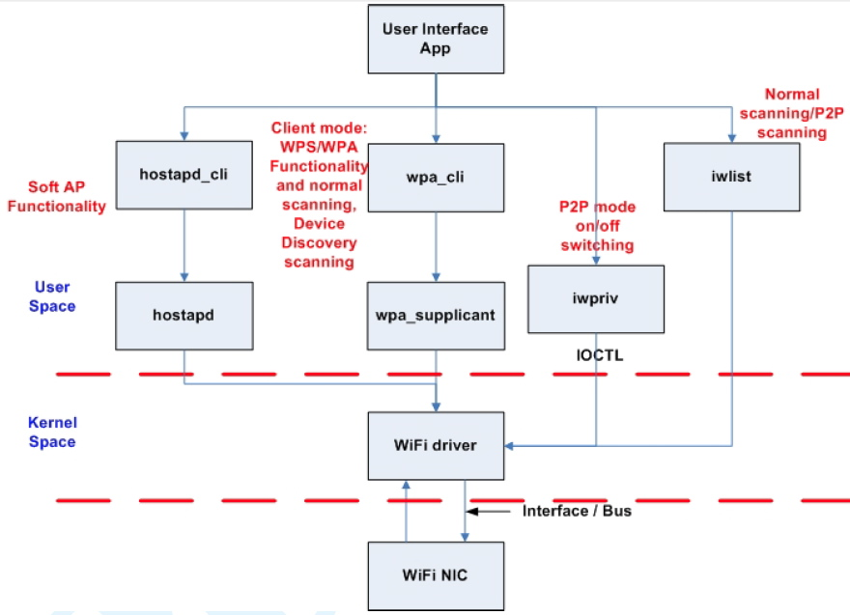

The iwpriv application is responsible for the communication to the Wi-Fi driver. With this application you can enable the p2p functionality of Wi-Fi direct.

If you want to establish a Wi-Fi direct connection, you need to go through 4 stages:

1. Device Discovery
2. Provision Discovery
3. Group Formation
4. Provisioning

In the following picture we see the workflow of a Wi-Fi direct connection process, including the 4 stages.

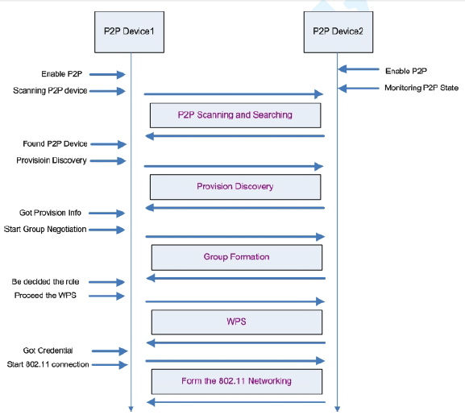

Let us go deeper into the different stages of this diagram:

# Enable P2P

In this stage both devices must be Wi-Fi direct compatible. With the iwpriv command, we can enable the Wi-Fi direct functionality on the Realtek driver. Following command is used:

iwpriv <interface name> p2p_set enable=<mode>

The interface name defines your wlan interface name from your raspberry. In most cases it will be wlan0. Wi-Fi direct can be enabled in different modes:

* enable=0: Wi-Fi direct will be disabled.
* enable=1: Wi-Fi direct will be enabled in Device mode.
* enable=2: Wi-Fi direct will be enabled in Client mode.
* enable=3: Wi-Fi direct will be enabled in Group owner mode.

# Scanning Devices

After enabling Wi-Fi direct, the device has to search for other Wi-Fi compatible devices. This can be done with wpa_supplicant/wpa_cli or iwlist command. We used iwlist, because wpa_supplicant/wpa_cli did not work on the raspberry pi. The iwlist command will be used as following:

iwlist <interface name> scan

The command will list Wi-Fi direct enabled devices only, if you wish to scan for 802.11 network devices like access points, you have to disable Wi-Fi direct functionality on the driver.

# Provisioning Discovery

The Provisioning Discovery is used to get the WPS Pin Code from the other device. There are several configurations which can be used. The command looks like this:

iwpriv <interface name> p2p_set prov_disc=<peer device mac address>_<mode>

The interface name is, as we mentioned before, wlan0. You also need the Mac address from the device, with which you want to establish a connection. The mac address is listed by doing a iwlist scan. The Provisioning Discovery offers 4 modes:

* display: The peer device will display its pin code, which the local device can use for pairing.
* keypad: This mode is the opposite of the display mode. The pin code will be displayed on the local device.
* pbc: In this mode, the devices are using the WPS push button procedure.
* label: In this mode the user should read the pin code from the label of the peer device and key-in this pin code of this label on the local device.

After the Provisioning Discovery a network connection between the two devices should be established.

To inform the driver from the successful connection process, the got_wpsinfo command is used.

iwpriv <interface name> p2p_set got_wpsinfo=<mode>

Mode definition:

* 1: Pin code was sent from peer device by showing on display or label.
* 2: Pin code was sent from local device to the peer device.
* 3: WPS PBC was used.

On the peer side, the device can check with the status command, if the connection was established. Status=08 means that connecting was successful. After the successful status the req_cm command should be used, to determine which WPS method was used. The result of this command will be returned as followed:

* CM=dis: Display
* CM=lab: Label
* CM=pbc: PBC
* CM=pad: Keypad

# Start group negotiation

In this stage will be determined which device should be group owner, a soft Access Point, and which should be the client which will connect to the access point.

Therefore the intent command is used:

Iwpriv <interface name> p2p_set intent=<intent value>

The intent value goes from 0 to 15.  If one peer has intent 15, it forces to be the group owner. Is the intent from the other peer lower, it will be the group client and will connect to the group owner.

Before the negotiation process can be started, a ssid should be sent to the driver if the device will become group owner in the future.

 iwpriv <interface name> p2p_set ssid=<ssid string>

After setting the ssid, the group negotiation command can be started.

iwpriv <interface name> p2p_set nego=<peer mac address>

The peer device should now monitor the negotiation with the status and role command. These enums define the return values of the commands:

enum P2P_STATE {

P2P_STATE_NONE = 0, // P2P disable

P2P_STATE_IDLE = 1, // P2P had enabled and do nothing

P2P_STATE_LISTEN = 2, // In pure listen state

P2P_STATE_SCAN = 3, // In scan phase

P2P_STATE_FIND_PHASE_LISTEN = 4, // In the listen state of find phase

P2P_STATE_FIND_PHASE_SEARCH = 5, // In the search state of find phase

P2P_STATE_TX_PROVISION_DIS_REQ = 6,// In P2P provisioning discovery

P2P_STATE_RX_PROVISION_DIS_RSP = 7,

P2P_STATE_RX_PROVISION_DIS_REQ = 8,

P2P_STATE_GONEGO_ING = 9, // Doing the group owner negoitation handshake

P2P_STATE_GONEGO_OK = 10, // finish the group negoitation handshake with success

P2P_STATE_GONEGO_FAIL = 11,// finish the group negoitation handshake with failure

P2P_STATE_RECV_INVITE_REQ = 12,// receiving the P2P Inviation request

P2P_STATE_PROVISIONING_ING = 13, // Doing the P2P WPS

P2P_STATE_PROVISIONING_DONE = 14, // Finish the P2P WPS

};

enum P2P_ROLE {

P2P_ROLE_DISABLE = 0,

P2P_ROLE_DEVICE = 1,

P2P_ROLE_CLIENT = 2,

P2P_ROLE_GO = 3

};

# Proceed the WPS

Depending on the confirmed roles, the device with role command response Role=02 should launch the wpa_supplicant in background and the wpa_cli with pin code or PBC to perform the WPS procedure. The Device with role command response Role=3, should use the hostapd in background and the hostapd_cli with pin code or PBC to perform the WPS procedure.

# DHCP

The device which is the group owner should also provide a DHCP-Server for IP Address exchange.

Prototype Raspberry pi:

The Raspberry Pi is a little linux based computer. In our case the linux distribution Raspbian (Debian for Raspberry) is used. The Raspberry Pi was developed for educational purpose und therefore offers a platform for learning the programming language Python. We also use a python script for our Prototype as well. First of all a shell script will be used for establishing the connection to another device over wifi direct. The script will guide the user through an installation setup.

1. Set a Name for your device
2. Raspberry will search for wifi direct enabled devices nearby. If a device is found, it will be displayed to the user. If not, the script has to be started again.
3. The user has to input the mac address from the wifi direct device.
4. The pairing process will begin.
5. If the pairing process was successful, a Python script will be started on the raspberry pi, which starts an udp-Server. It will listen for incoming Messages.
6. The wifi direct device has to start the udp-Client. It should be sending a message to the server, which will display it in the commandline.